**WISC in CLIMADA** 20180131

Part of <https://github.com/davidnbresch/climada_module_storm_europe>

David N. Bresch, [dbresch@ethz.ch](mailto:dbresch@ethz.ch)

The CLIMADA[1] winter storm module[2] provides a solid basis to test and further develop the WISC[3] storm catalog[4] (4.4 km spatial resolution, time period 1940-2014). The present document does briefly touch upon some first tests and attempts to further develop this catalog within CLIMADA. Most results (and some intermediate files, too) can be found on the polybox[5].

CLIMADA operates on a variable grid, defined by *centroids*. For most calculations, CLIMADA hence uses just the grid the WISC footprints are provided at (4.4km) for all hazard analytics. Please note that for any impact calculations, CLIMADA does automatically assign each exposure point with the closest hazard centroid (i.e. the closest (variable) grid point of the hazard). This way, CLIMADA can handle irregular and dissimilar grids very elegantly.

In order to import all historic wind field footprints into CLIMADA, use wisc_hazard_set[6]. To generate the *historic* hazard set, i.e. with all historic WISC footprints, just visit <https://wisc.climate.copernicus.eu/wisc/#/help/products>, download C3S_WISC_FOOTPRINT_NETCDF_0100.tgz and unzip into a subfolder named WISC of your local climada_data folder, then run:

wisc_files=[climada_global.data_dir filesep 'WISC' filesep ...  
 'C3S_WISC_FOOTPRINT_NETCDF_0100' filesep 'fp_era*.nc'];

**hazard**=wisc_hazard_set(wisc_files)

Figures 1-3 as shown below are based upon this data in **hazard**.

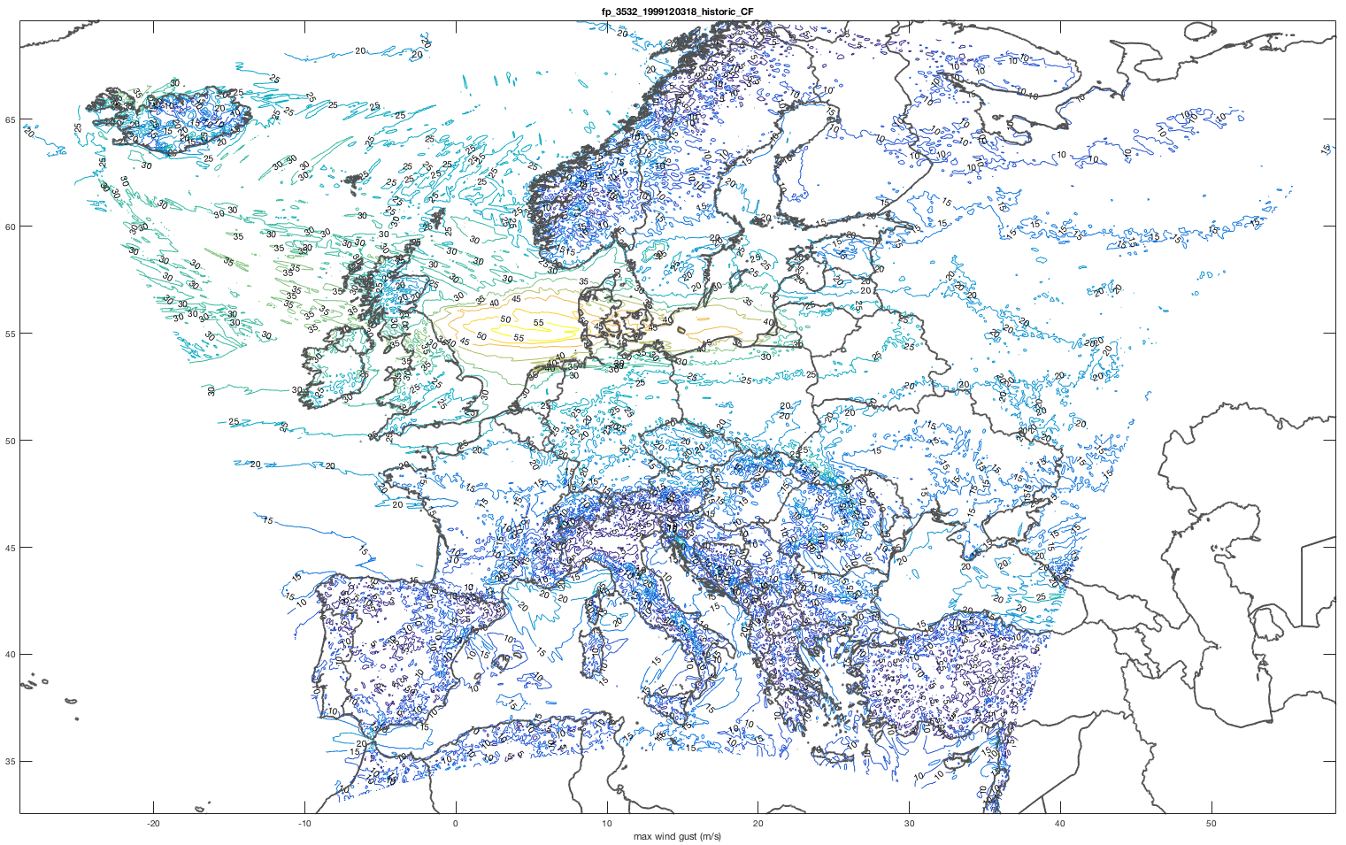

Figure 1: A single WISC storm footprint (1999120318, Anatol) imported by wisc_hazard_set and plotted as contours (wind speed in m/s, for details, see WISC documentation).

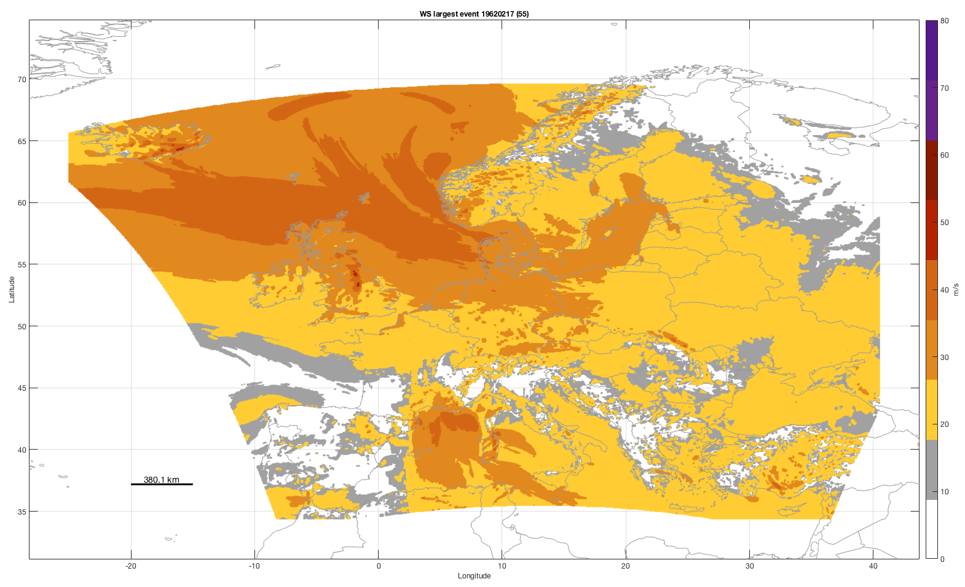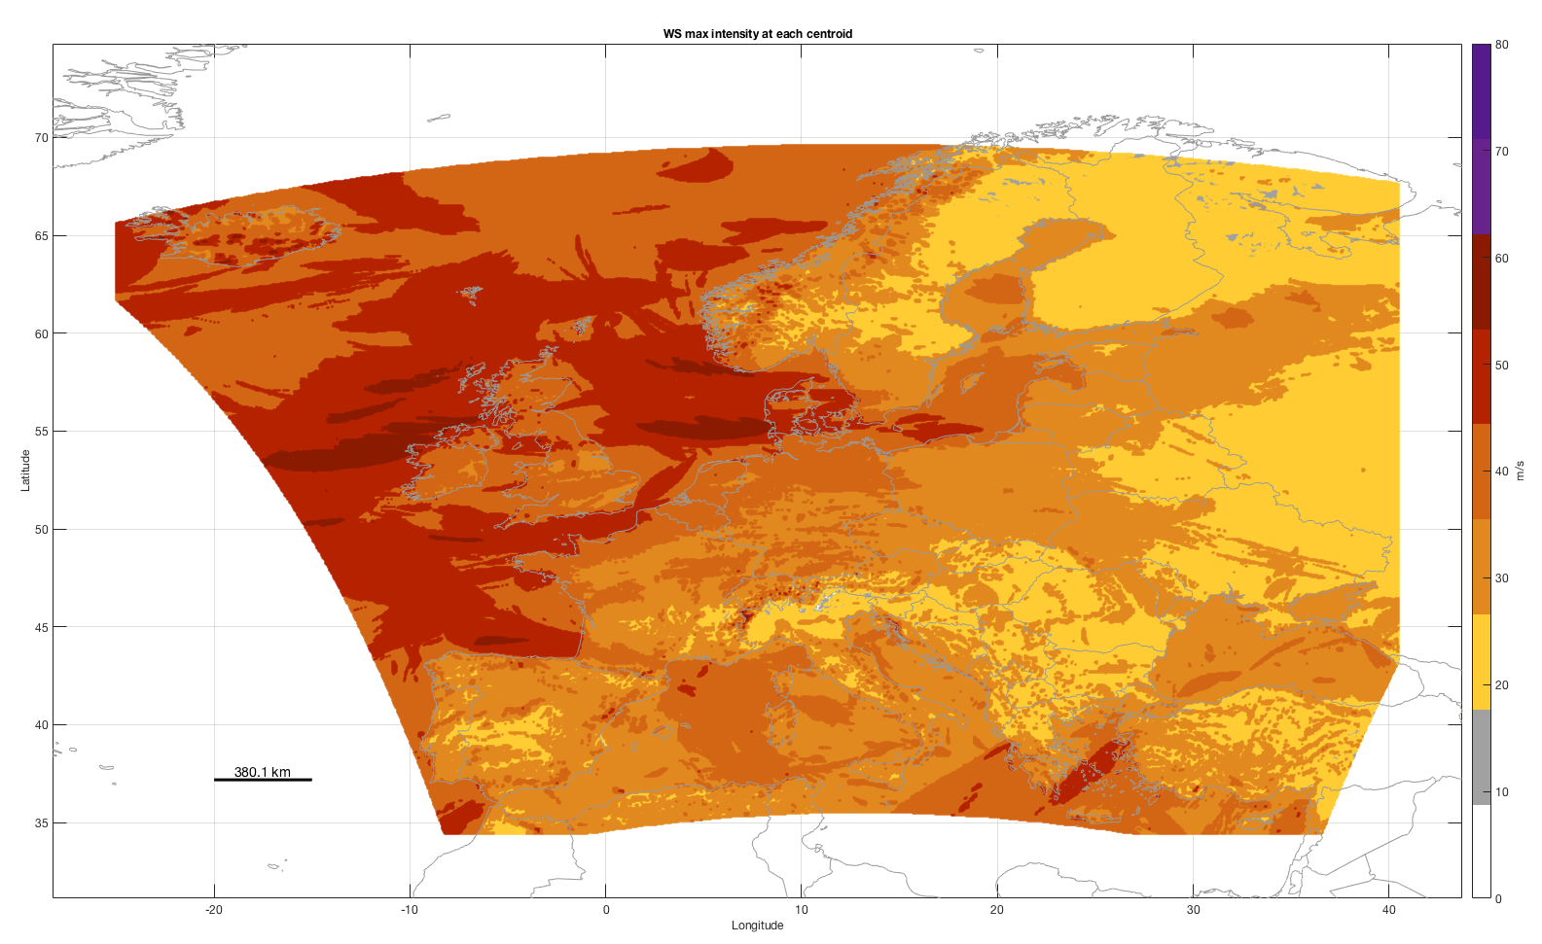

Figure 2: The largest single event (19620217) and the maximum intensity of all historic (era40 and eraint, time period 1940-2014) events at each centroid. Easily produced by the call climada_hazard_map(hazard,-1) for the left and climada_hazard_map(hazard,0) for the right plot. CLIMADA can obviously render with larger fonts etc. – the plots were just produced to show best on a large screen…

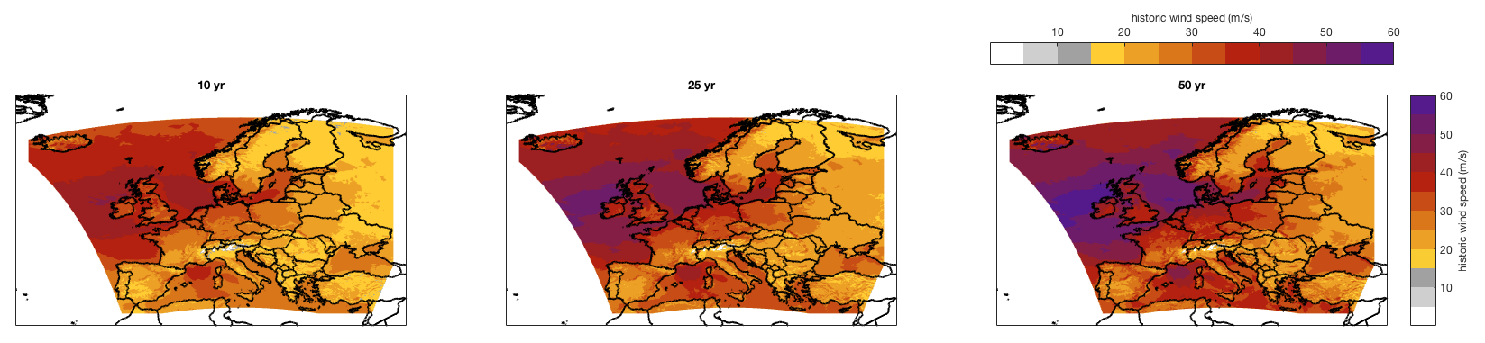

Figure 3a: Wind speed return period maps. Shown are return period maps for 10, 25 and 50 years, wind speed in m/s based on *historic* events. The plot has been automatically produced by the call climada_hazard_stats(hazard,[10 25 50]). Note that the color scale shows grey up to wind speeds that hardly lead to any impact (15 m/s) and then aligned with the tick marks up to a max gust of 60 m/s.

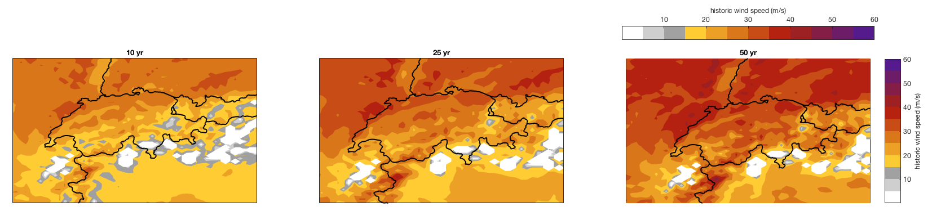

Figure 3b: Same as Fig. 3a, just zoomed in for Switzerland.

CLIMADA does allow for an easy generation of a *probabilistic* hazard event set, i.e. storm catalog based on *historic* events being moved a bit around (see Figure 4) and weakened and intensified. While the moving around allows for an easy way to deal with hazard uncertainty in impact calculations (a single storm might have happened a bit North/South/East/West of the original one), the weakening/intensification does extend the range to include storms which are physically plausible (or possible) but did not happen so far. Obviously, the relative frequencies are adjusted in CLIMADA accordingly.

Please note that the full European WISC grid has 1.6 million points. While calculations for the 148 historic storms can still be performed without RAM swapping and other performance issues, any probabilistic set with more than about ten times the number of original events easily blows the memory. Therefore, we implement all *probabilistic* hazard set generation by country.

As for the historic hazard set, the generation of the *probabilistic* set is another one line of CLIMADA code:

wisc_hazard_set_prob('',hazard)

with hazard the *historic* hazard, or, to run one single country (here for UK), just

wisc_hazard_set_prob('GBR',hazard)

Please note that wisc_hazard_set_prob does always store single-country hazard sets (for memory and performance reasons). See wisc_hazard_stats below for an example how to loop over all countries.

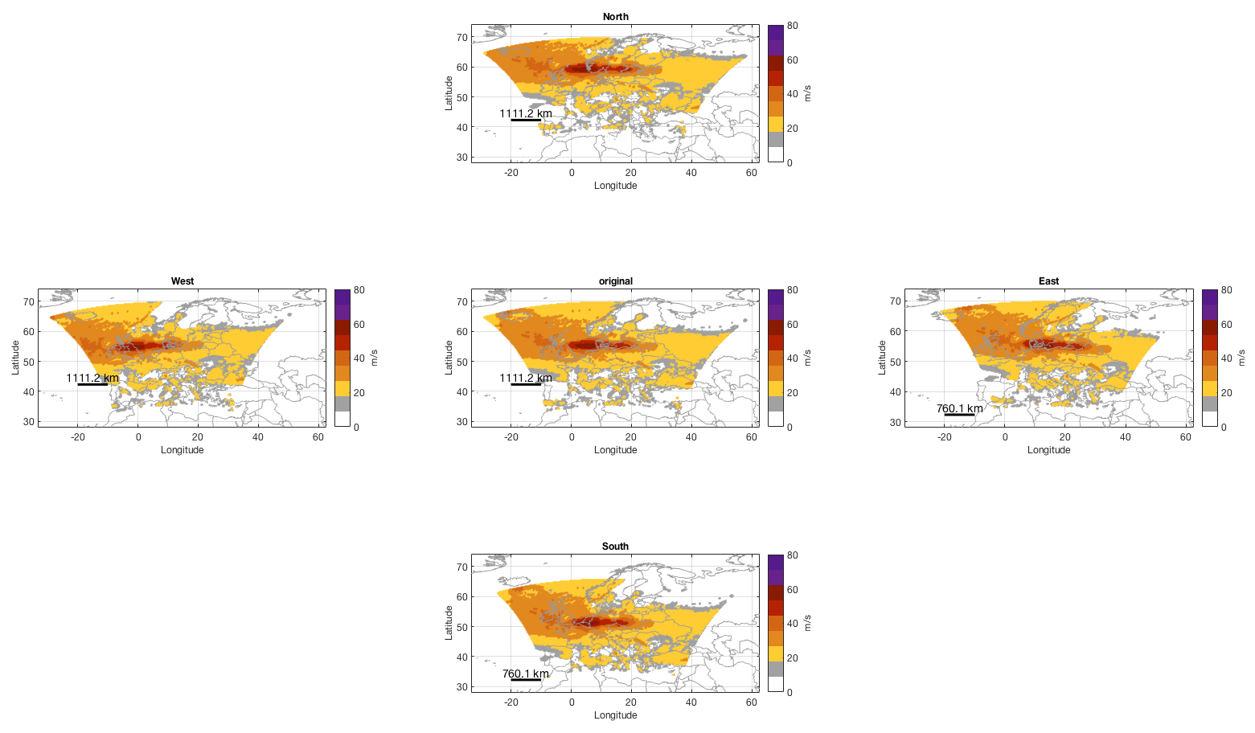

Figure 4: Schematic of the derived spatial ‘siblings’ (in the respective directions) of an original WISC footprint (Anatol, 1999, at the center). The spatial translation is hugely exaggerated (here about 100km) for illustrative purposes only. In the real case, the ‘wiggle’ is by a mere one or two grid points (4.4 or 8.8 km). Generated by climada_ws_hist2prob (a low-level function, usually called by wisc_hazard_set_prob).

In order to check whether the synthetic catalog does not under- or overestimate event intensities compared to the historic catalog, we employ storm severity index statistics according to Lamb (1990), as shown in Figure 5. Again, these statistics can easily be generated on any WISC hazard set by simply invoking wisc_hazard_stats.

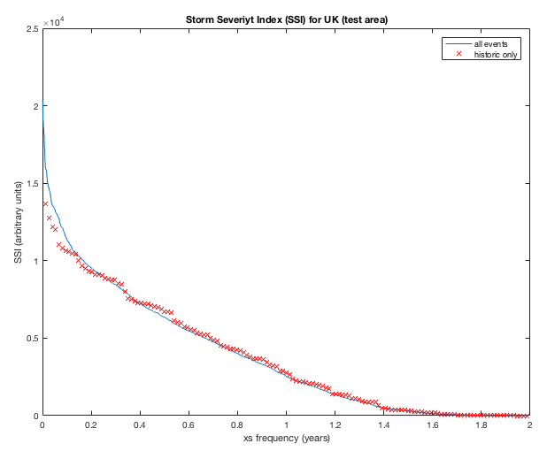

Figure 5: Storm Severity Index (SSI) for both the historic and synthetic set for the United Kingdom. We show the UK results, since the probabilistic severity distribution is a bit heavier than historic for rare events, while it matches even better or very well for most other countries. But before spending too much time on tinkering with the probabilistic event set generation, the full chain of impact shall be completed. See Appendix A2 for single country SSI figures.

Similar to the historic set, return period maps can be drawn, but now obviously for much higher return periods, see Figure 6.

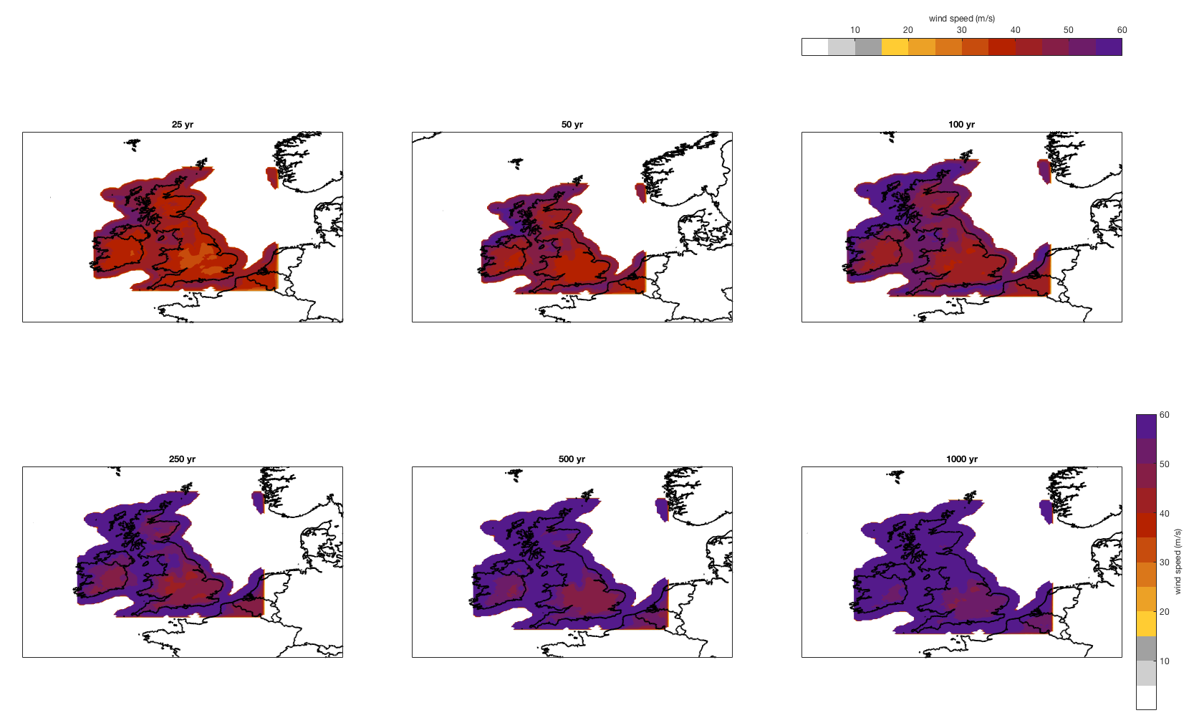

Figure 6: Hazard intensity return period maps for United Kingdom for return periods of 25, 50, 100, 250, 500 and 1000 years. Figure created by climada_hazard_stats(hazard,[25 50 100 250 500 1000],1) for hazard containing the *probabilistic* set for UK.

Last but not least, CLIMADA allows to quantify winter storm impacts, as shown in Fig. 7 for UK.

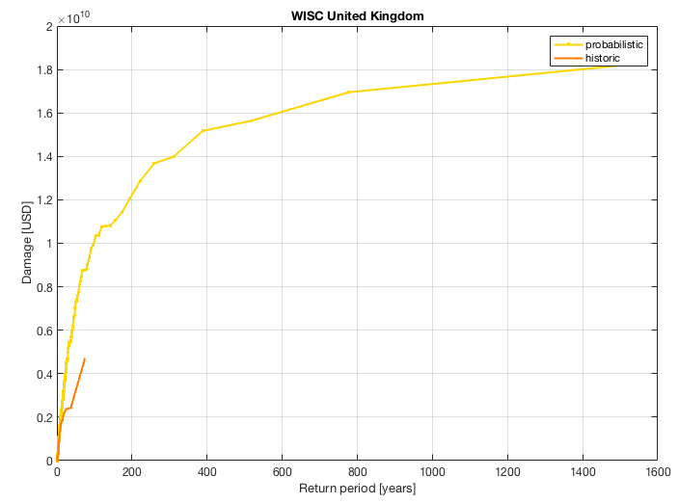

Figure 7: Impact of winter storms on UK, a quantification of UK winter storm risk. Quantification based on a standard asset portfolio for UK, see CLIMADA for details (see climada_entity_country('GBR') for automatic generation of the asset base).

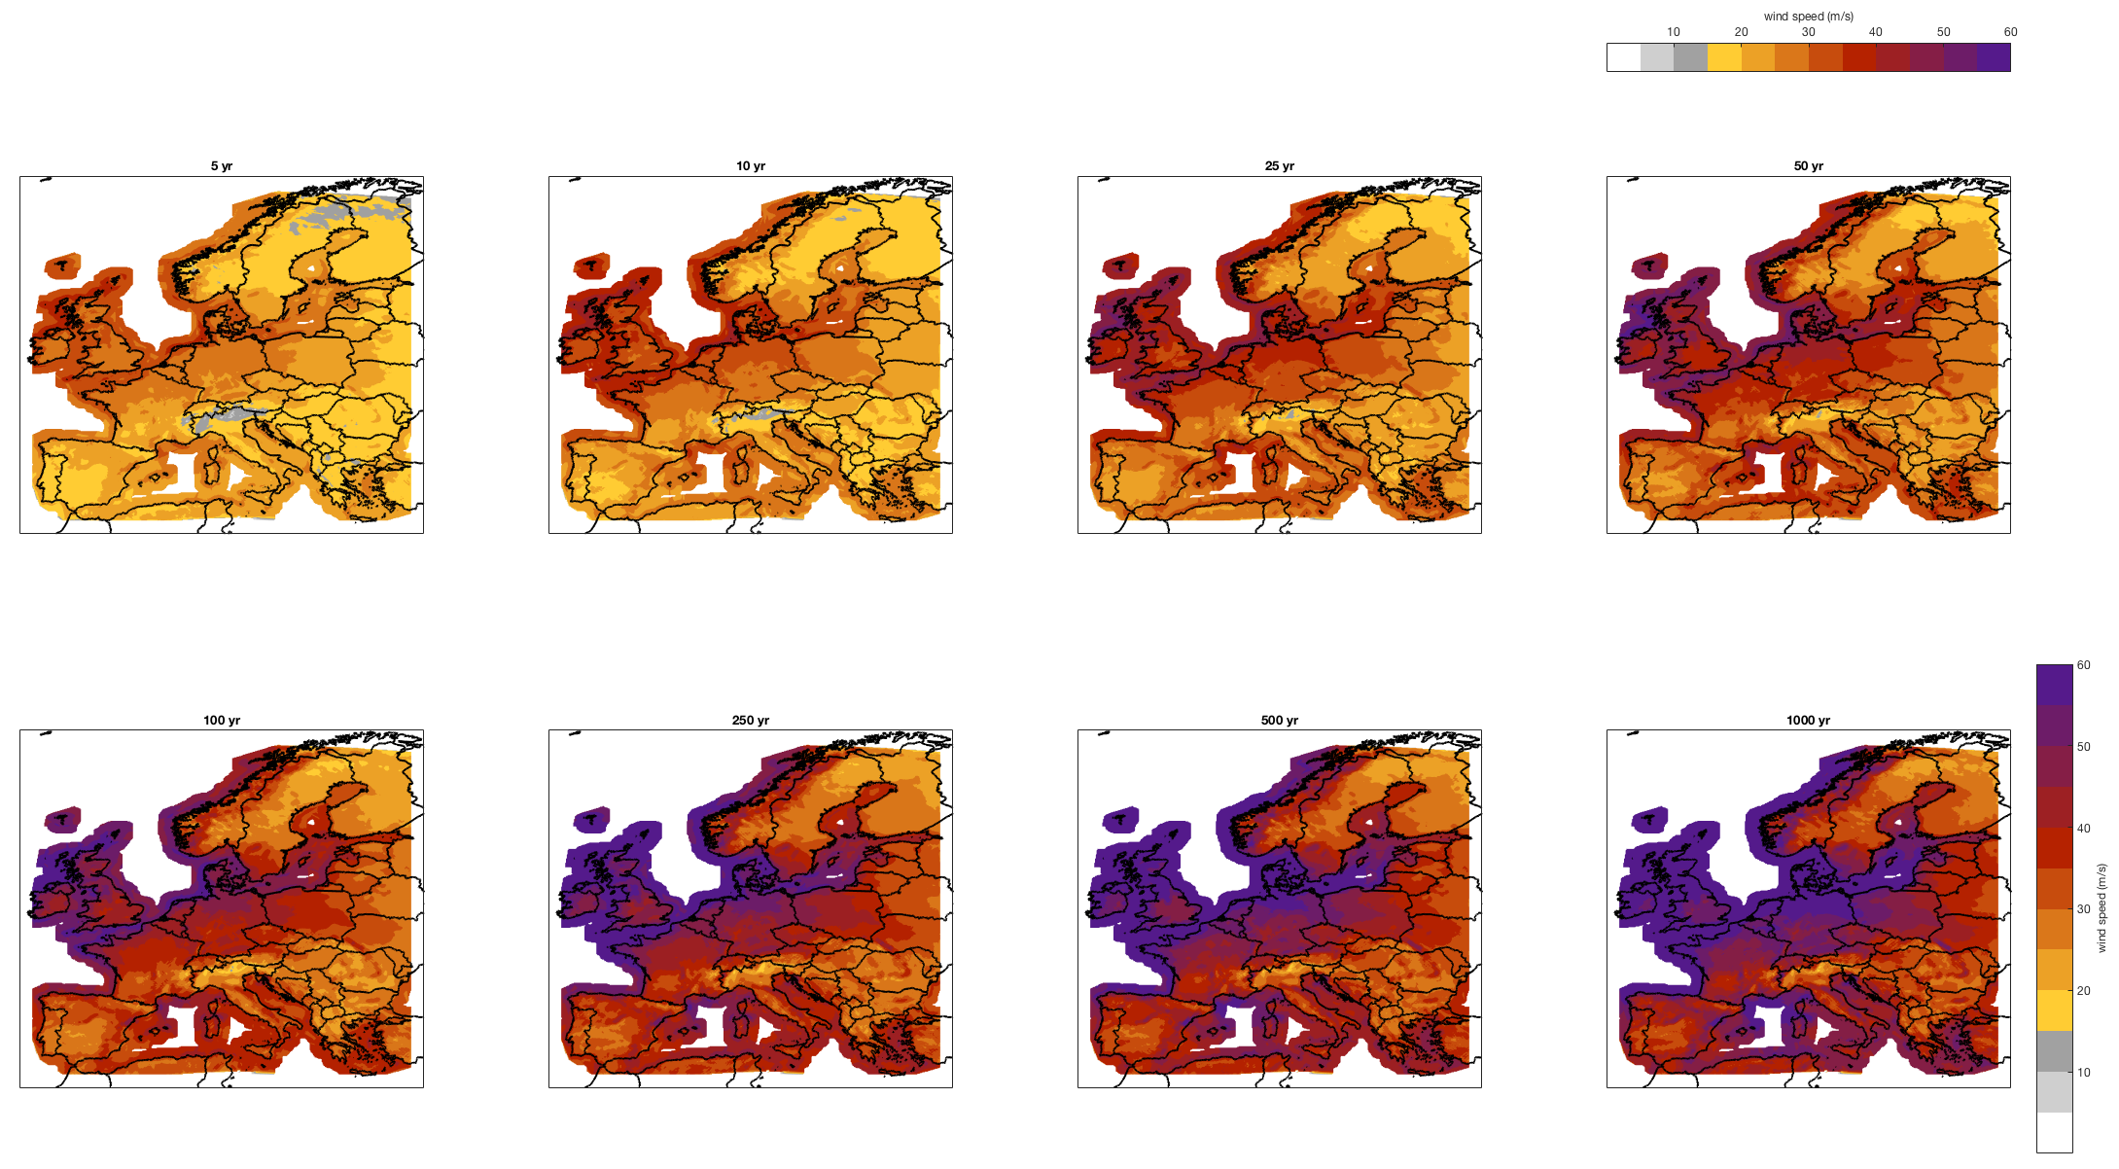

Figure 8: Wind speed return period maps for the synthetic set. Shown are return period maps for 5, 10, 25, 50, 100, 250, 500 and 1’000 years, wind speed in m/s. The plot has been automatically produced by the call[7] wisc_hazard_stats([ 5 10 25 50 100 250 500 1000]). Note that the color scale shows grey up to wind speeds that hardly lead to any impact (15 m/s) and then aligned with the tick marks up to a max gust of 60 m/s. Compare with Figure 3a.

CLIMADA does also provide functionality to assess local wind climatology, i.e. to plot wind gust for return periods etc. (Figure 9).

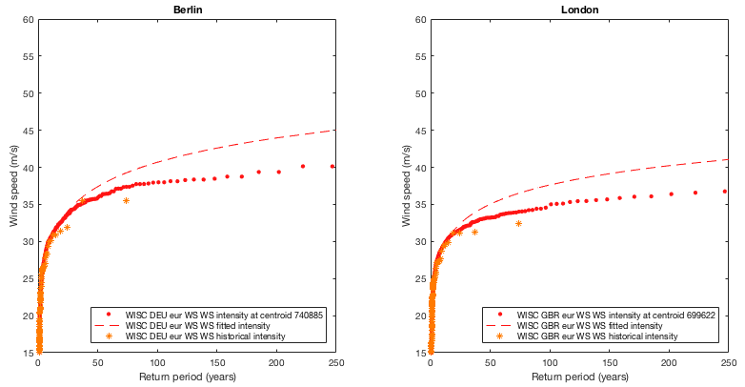

Figure 9: Wind speed return period plot for Berlin. Automatically produced as follows:

hazard_DEU=climada_hazard_load('WISC_DEU_eur_WS'); % load hazard set

hazard_GBR=climada_hazard_load('WISC_GBR_eur_WS'); % load hazard set

Berlin.lat=52+31/60;Berlin.lon=13+24/60; % define coordinate

London.lat=51+31/60;London.lon= 0-07/60; % define coordinate

figure;subplot(1,2,1);climada_IFC_plot(climada_hazard2IFC(hazard_DEU,Berlin));

xlim([0 250]);ylim([15 60]);title('Berlin');

subplot(1,2,2);climada_IFC_plot(climada_hazard2IFC(hazard_GBR,London));

xlim([0 250]);ylim([15 60]);title('London');

Appendix

Figure A1 (next page): Wind speed return period maps for the *probabilistic* set for Switzerland. Shown are return period maps for 5, 10, 25, 50, 100, 250, 500 and 1’000 years, wind speed in m/s. The plot has been automatically produced by the call wisc_hazard_stats(hazard,[ 5 10 25 50 100 250 500 1000]). Note that the color scale shows grey up to wind speeds that hardly lead to any impact (15 m/s) and then aligned with the tick marks up to a max gust of 60 m/s. Compare with Figure 3a.

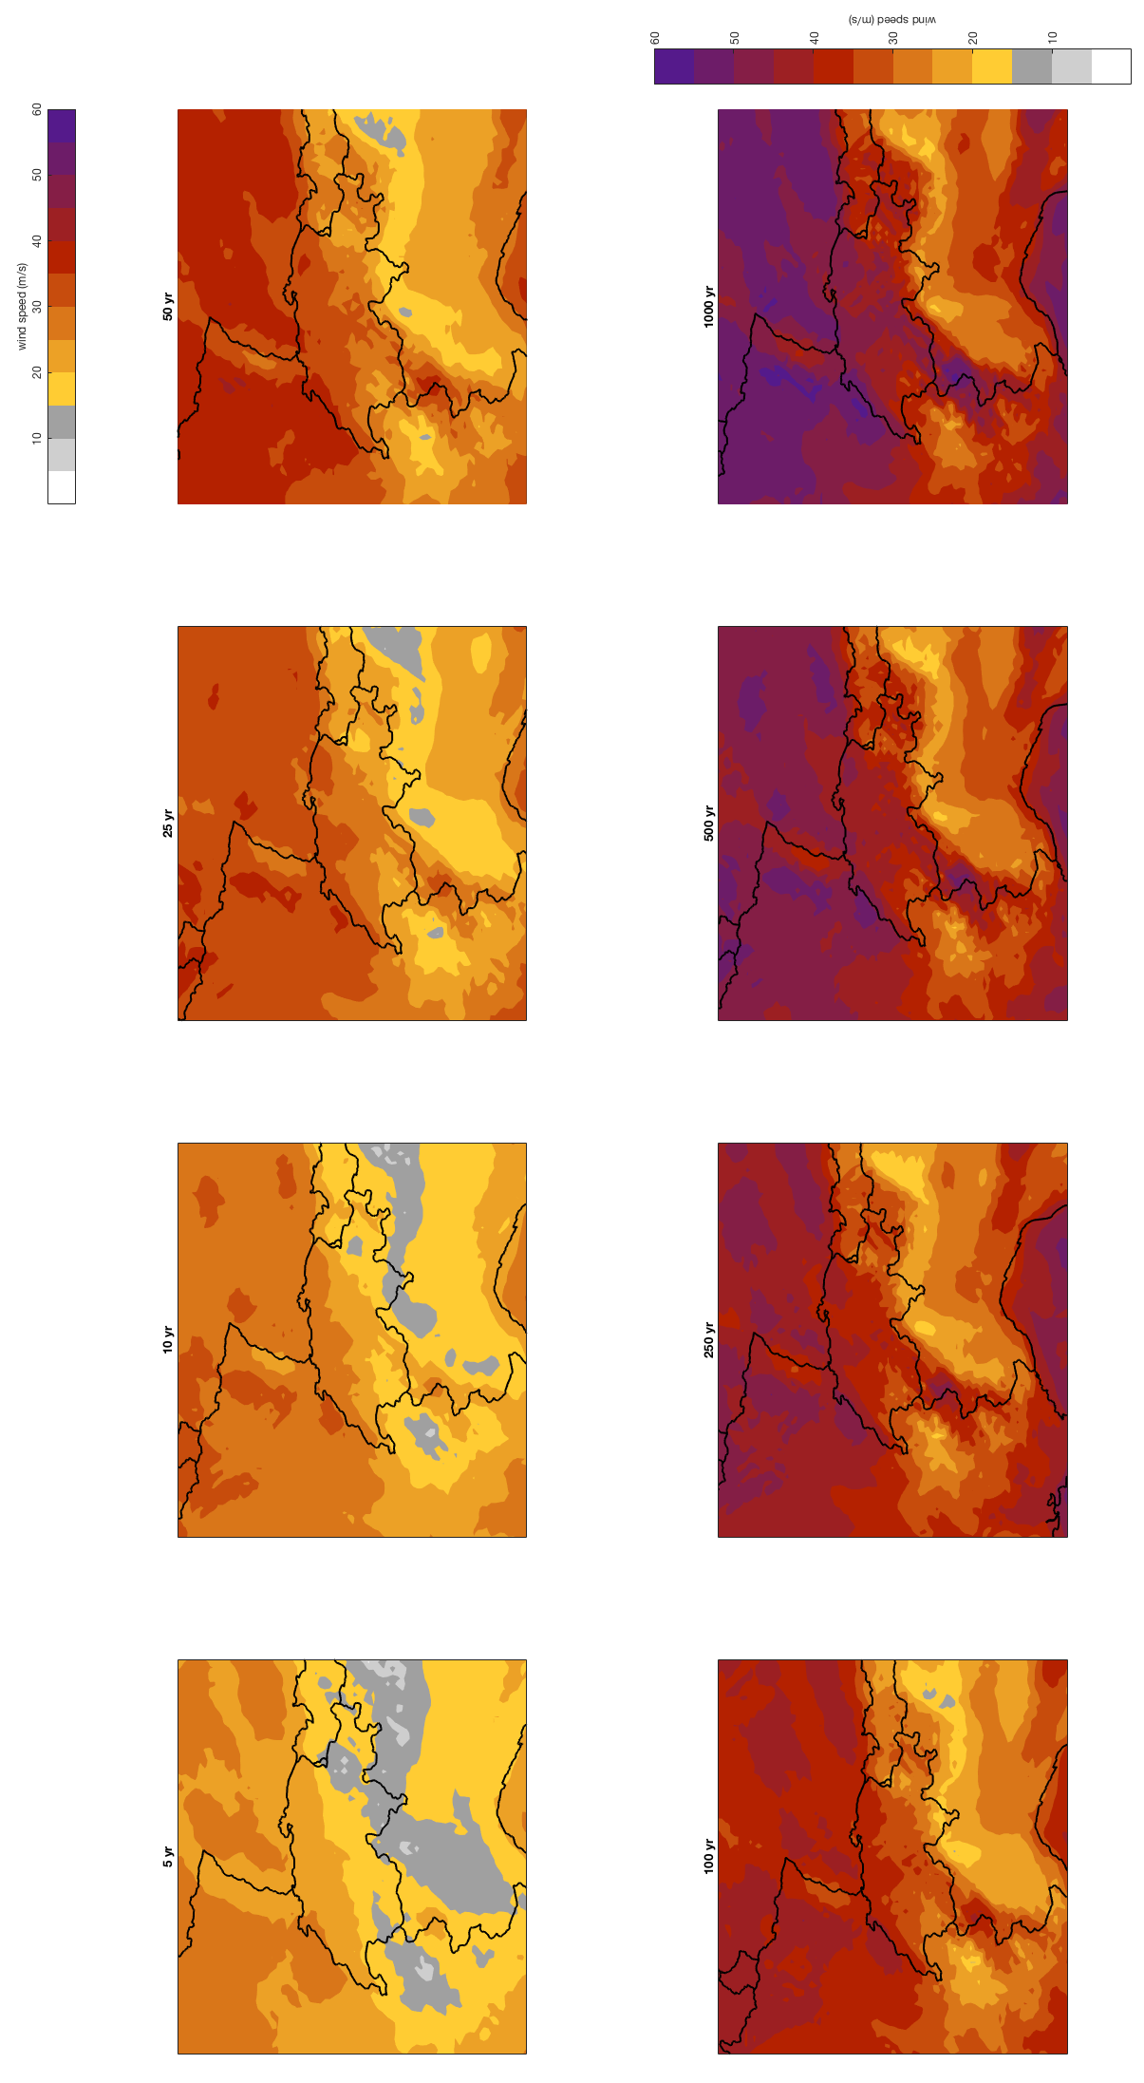

Figures A2 (below): Storm severity index plots for all European countries, generated by the call [~,combined_ssi,country]=wisc_hazard_stats([],1,2).

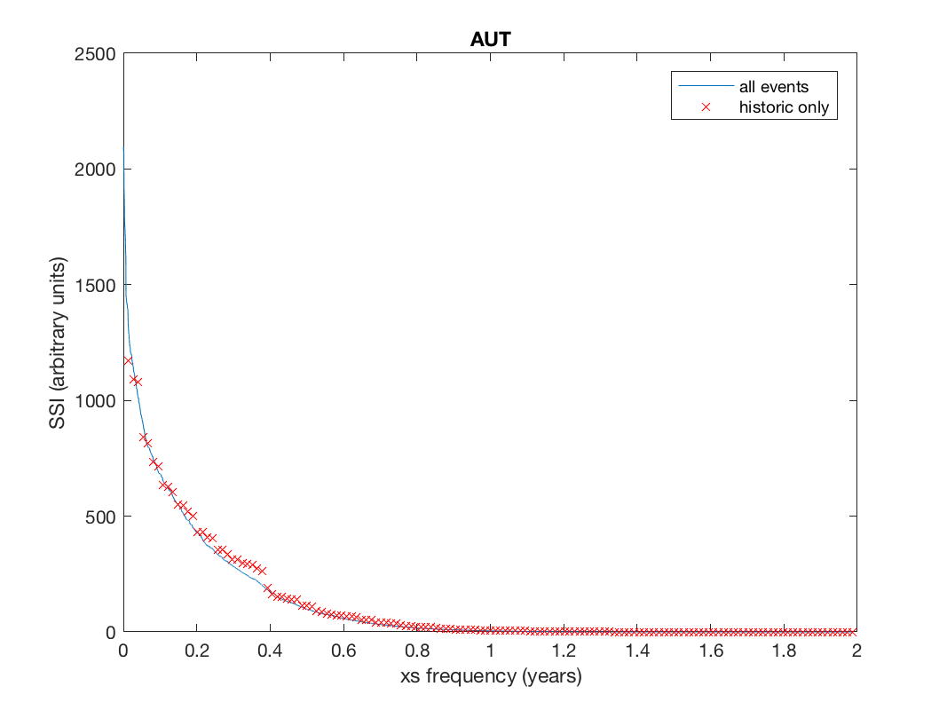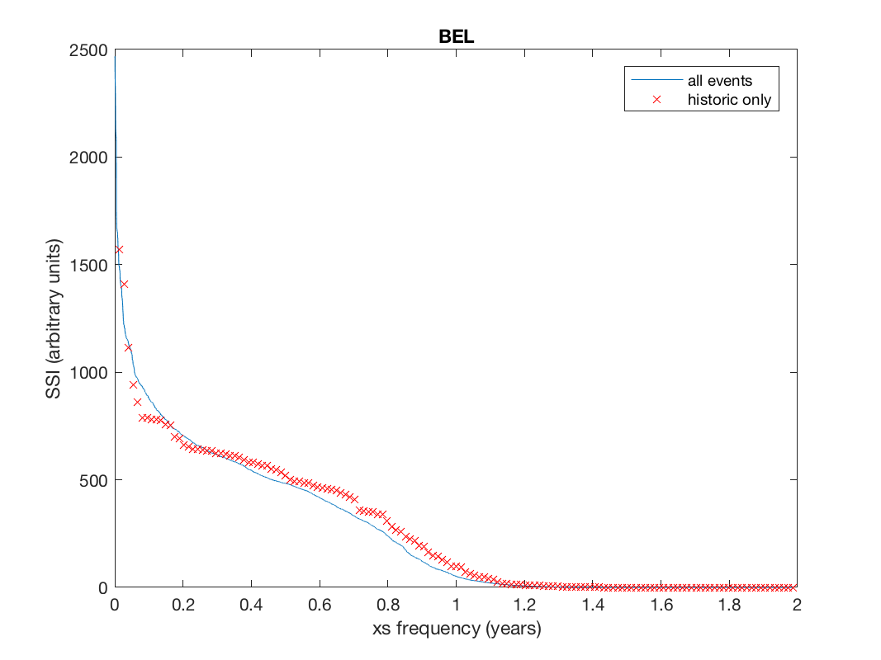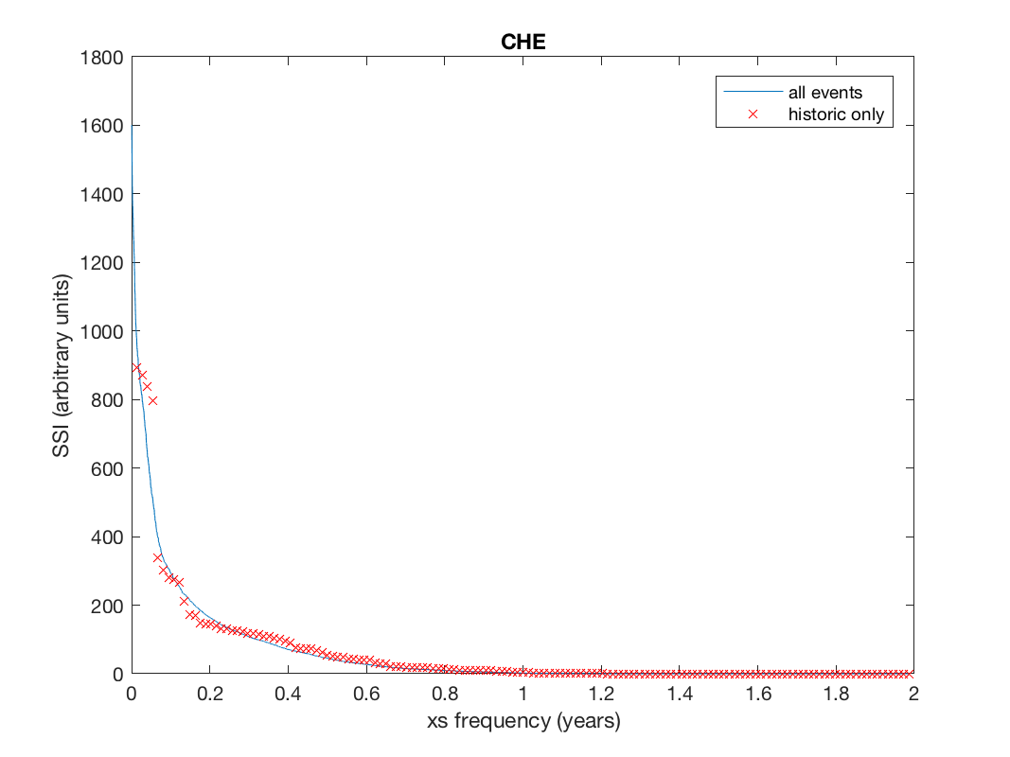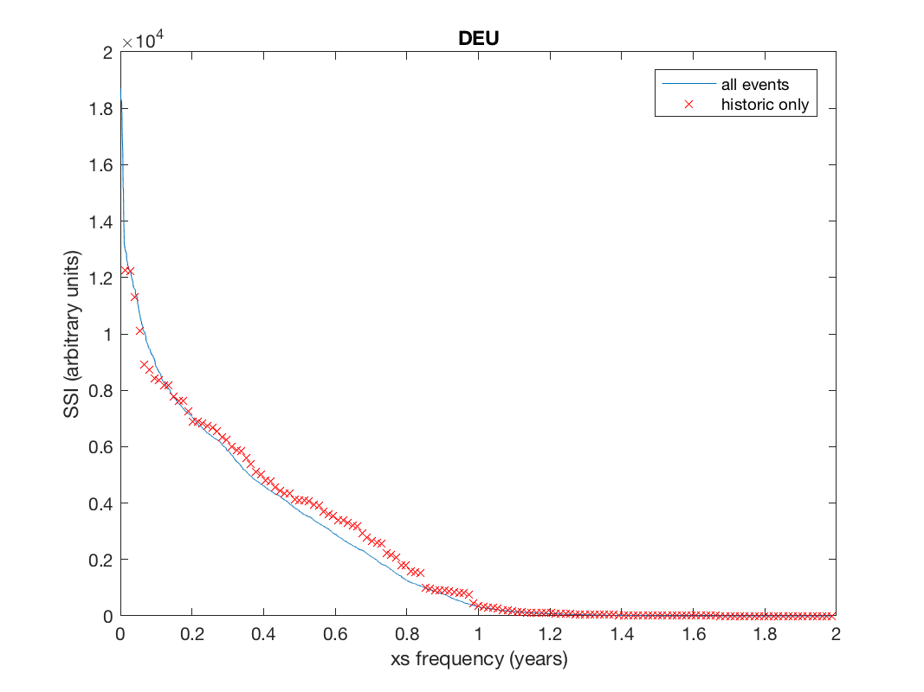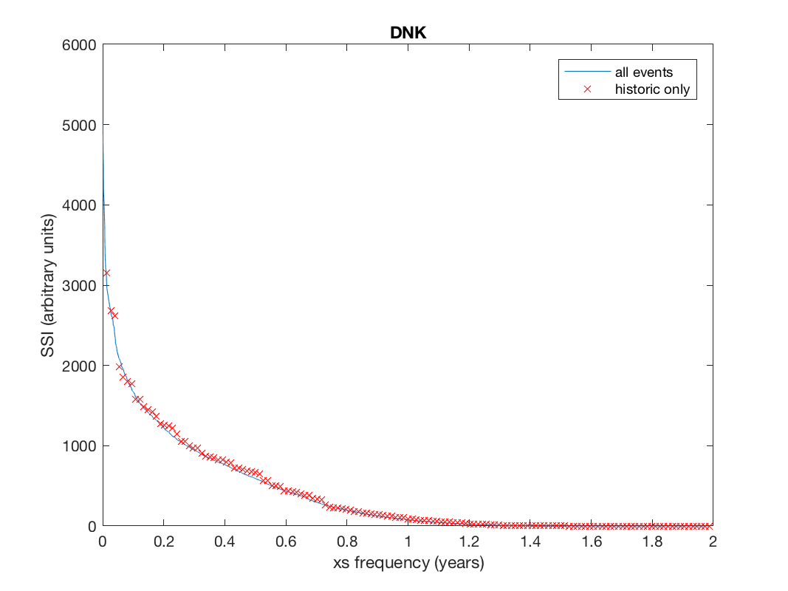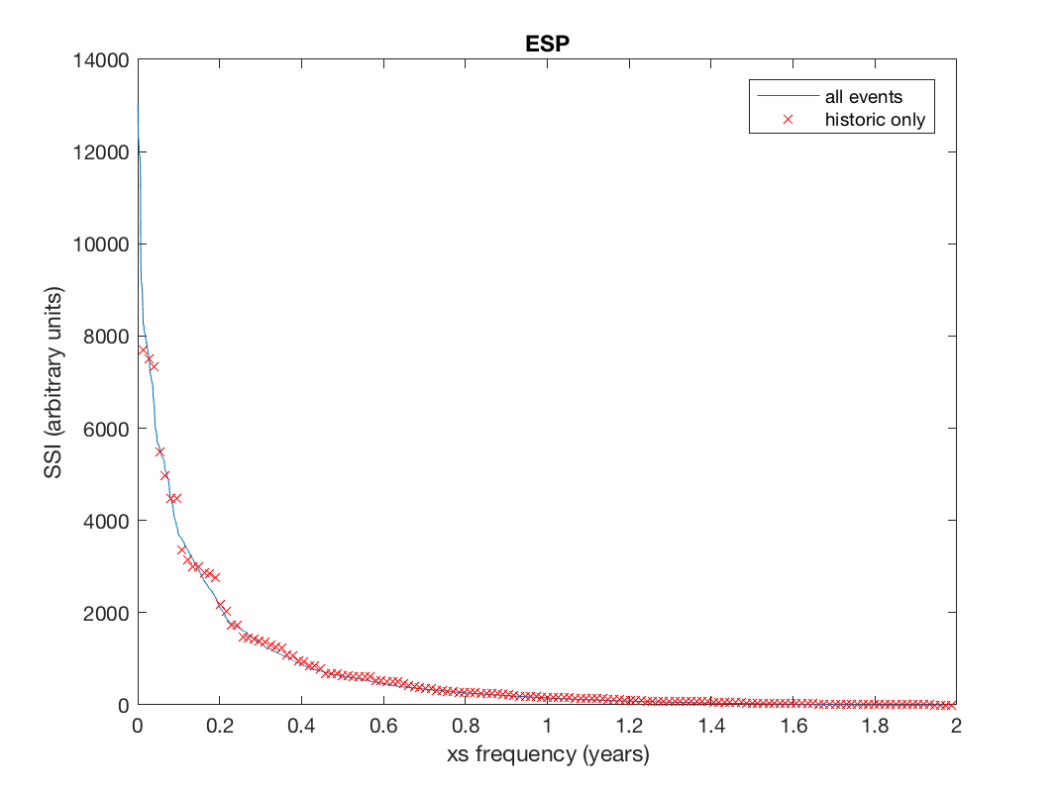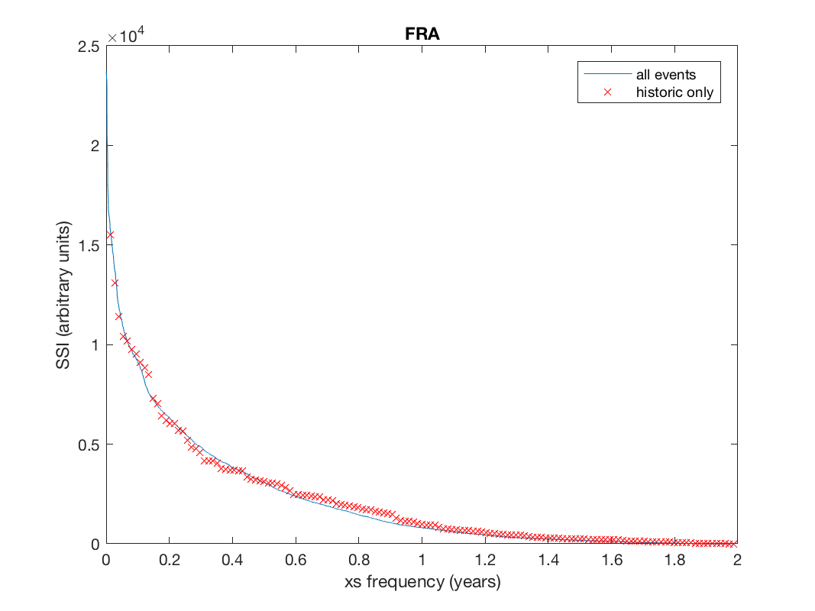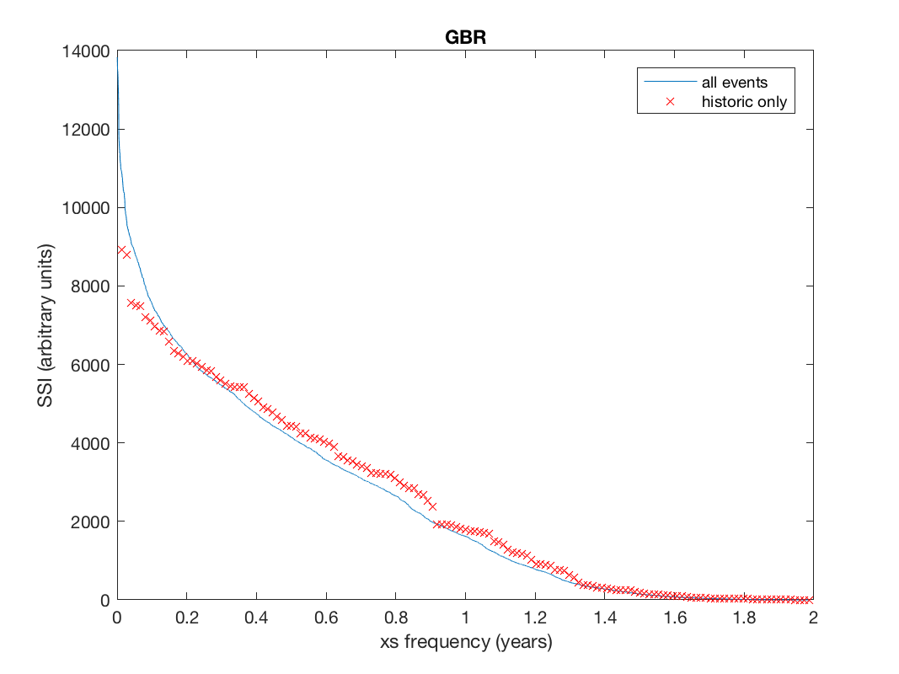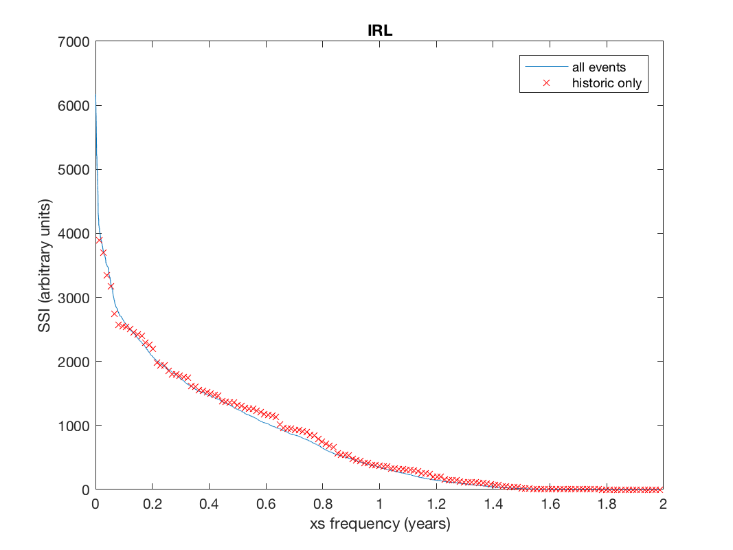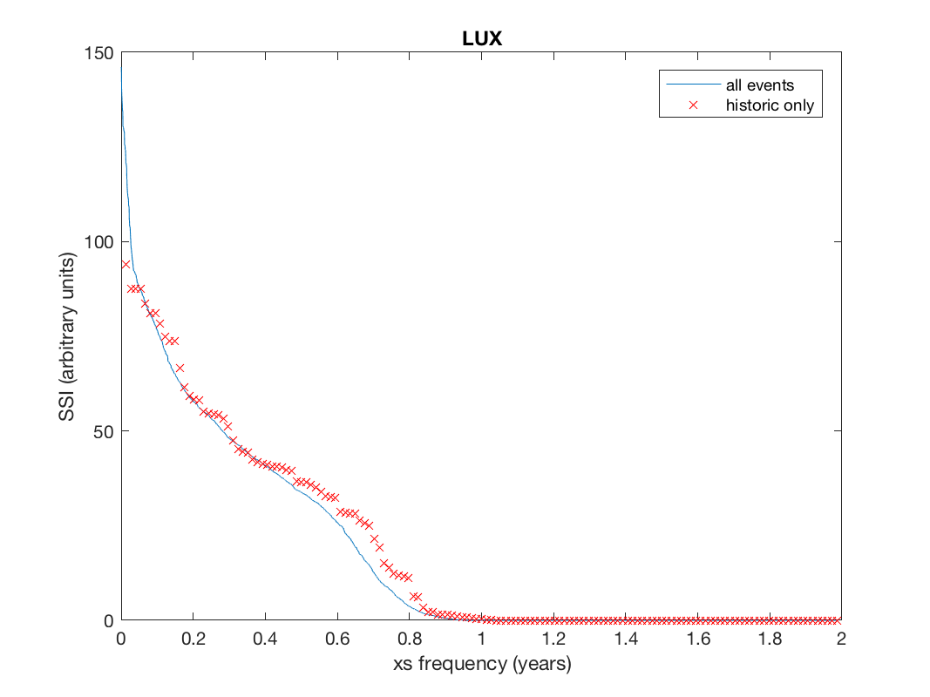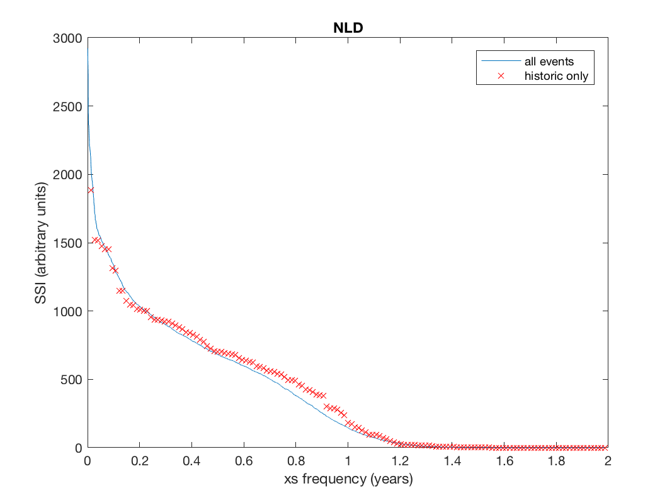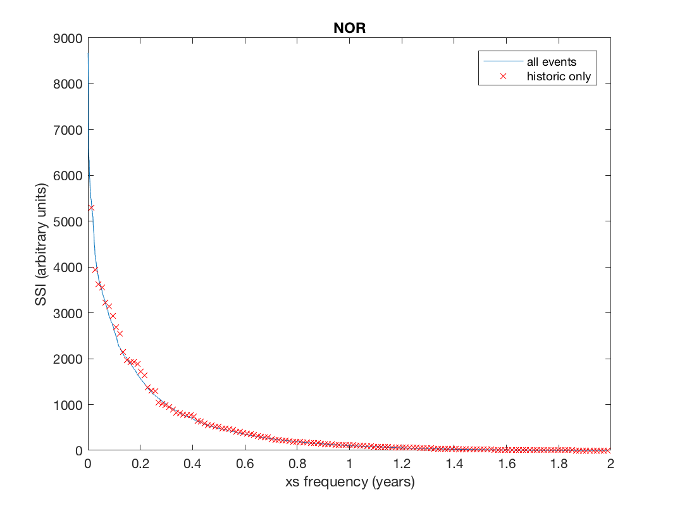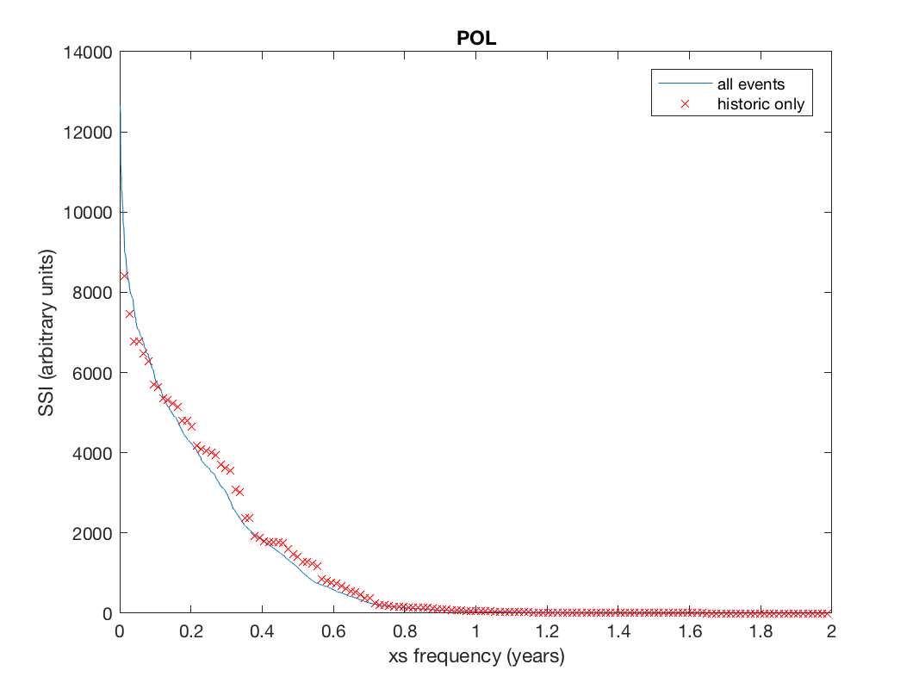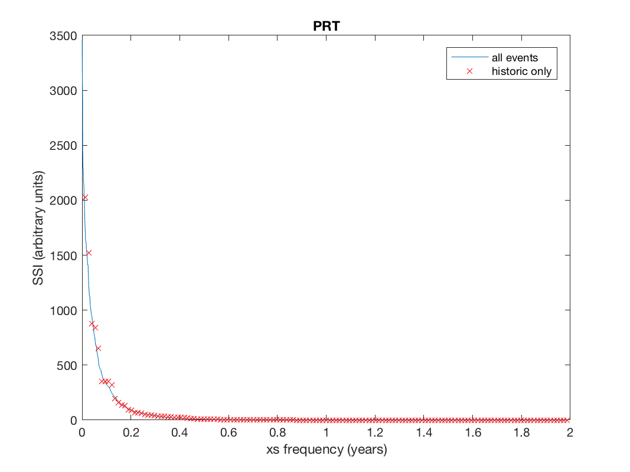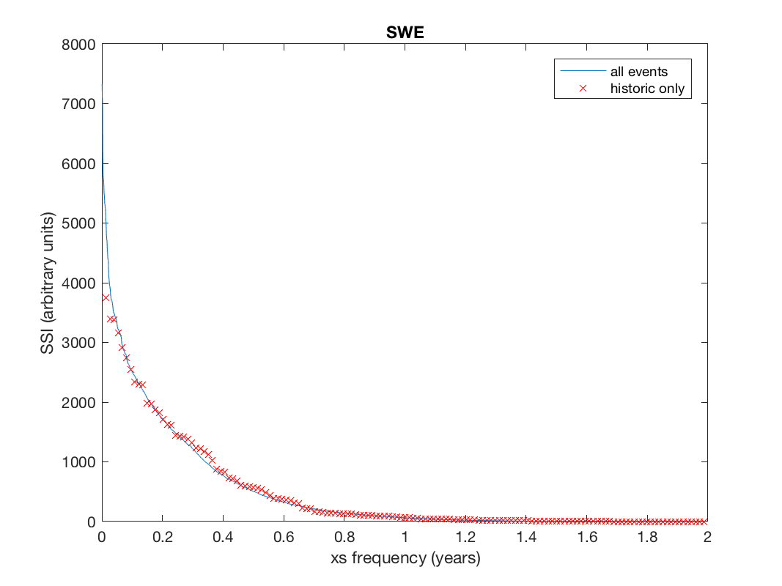

and the combined SSI curve:

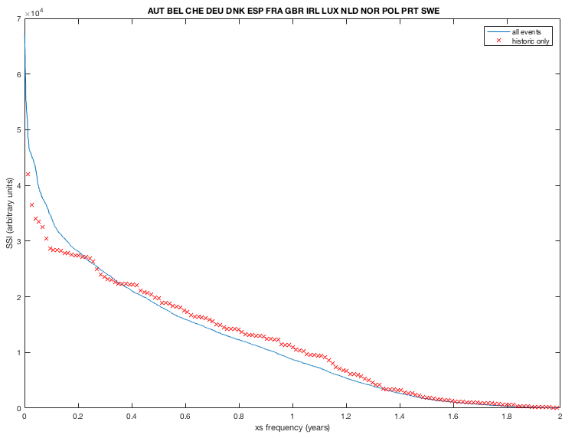

1. <https://github.com/davidnbresch/climada>
2. <https://github.com/davidnbresch/climada_module_storm_europe>
3. <https://wisc.climate.copernicus.eu>
4. <https://wisc.climate.copernicus.eu/wisc/#/help/products>
5. <https://polybox.ethz.ch/index.php/s/yO1sCMuSFA2qdGR> and subfolders of the same structure as in CLIMADA. In order to use these files, just copy them to your local CLIMADA data folder (…/climada_data/hazards … etc.)
6. CLIMADA commands are formatted as Courier New and can usually just be typed into the MATLAB command window once CLIMADA has been started.
7. This call invokes climada_hazard_stats, as it loops over all *probabilistic* WISC hazard event sets previously generated by wisc_hazard_set_prob.